Week 1 – Introduction to Big Data
Mastering Big Data requires mastering tools, and this week’s assignment is dedicated to setting up our environment. Using Google Cloud, we will create a virtual machine and host our tools in the cloud. As mentioned in the lecture, data processing for megabytes and gigabytes of data can be done locally without special tools, but once we process terabytes and petabytes, we must be familiar with special tools such as Solr, Hadoop, Spark, and Kafka. These operations often will not be run on our local machines but instead on the cloud, where specialized computers process handle the processing.
Step 1. Creating Virtual Machine
This was relatively straightforward. Utilizing the free tier for Google Cloud, we created a virtual machine. The VM uses the Ubuntu 25 Linux distribution and contains 4 CPUs, 8GB memory and 50 GB storage.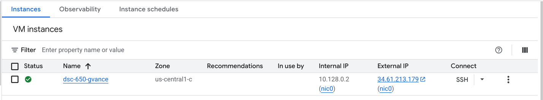
Step 2. To connect to the VM from our terminal, we generated an ssh key (truncated output below).
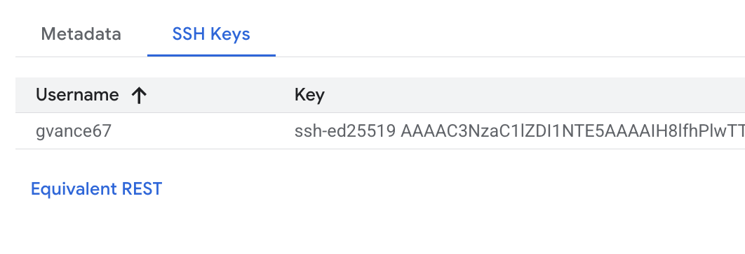
We also modified the network access and copied the IP address for ssh purposes. 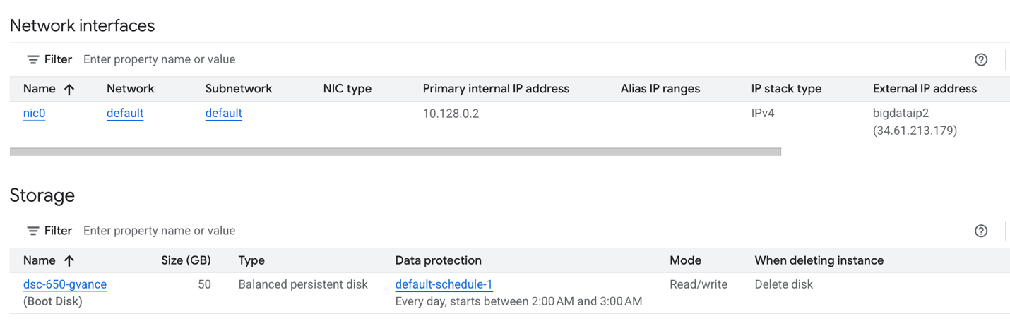After verifying SSH tunnels, we were ready to connect to our VM. These instances will always be live when SSH’ing to our machine.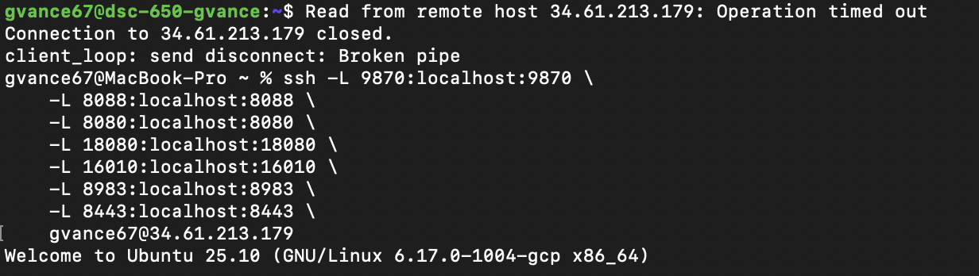
After connecting to the VM, we clone the Bellevue Big Data git repo.
Inside of the repo we had 4 projects: Hadoop, Kafka, Solr and Nifi. Docker images can quickly be spun up using the docker compose inside each directory. This allows us to create images with all the required technologies and deploy web servers available on our local device. Here are the deployed results: 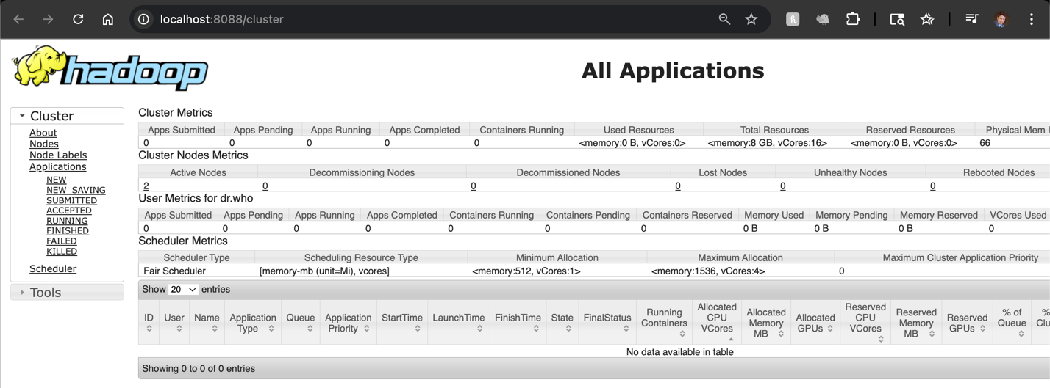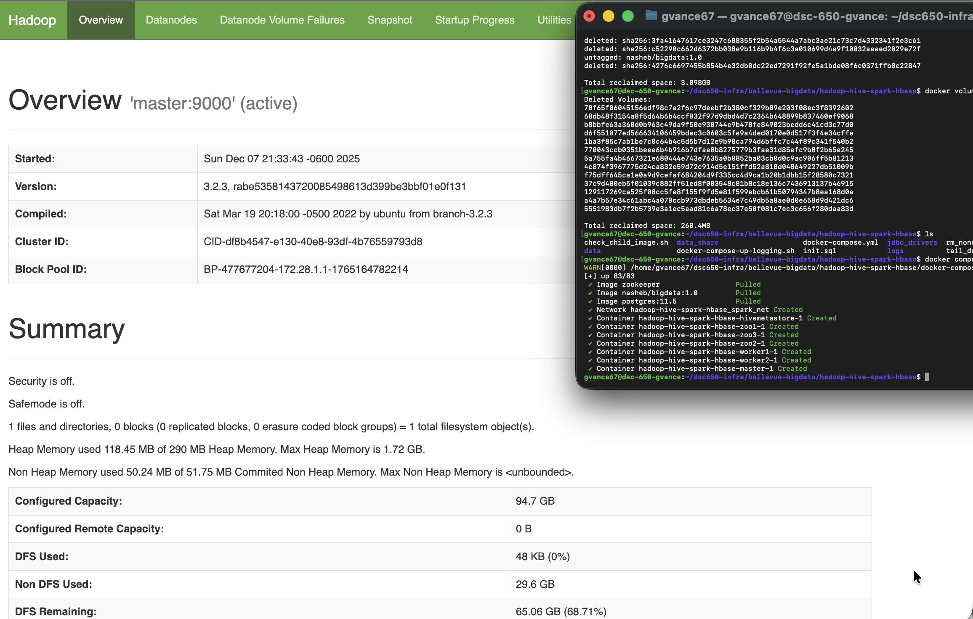
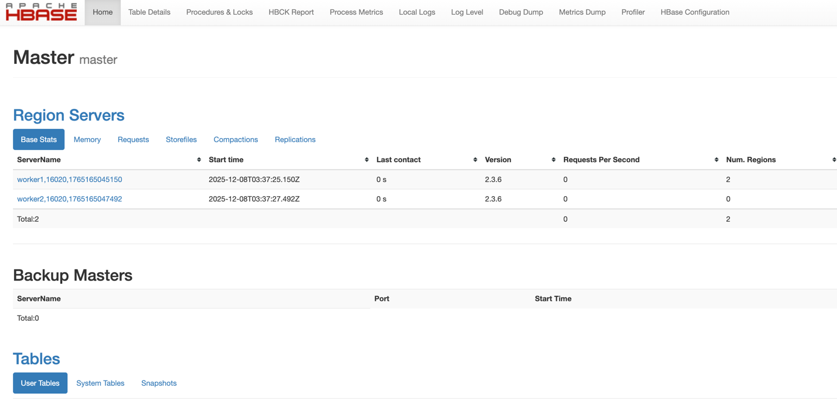
As a result of the docker compose command run in the Hadoop folder, we now have HBase application deployed on port 16010, Hadoop on 8088/cluster, and the HDFS NameNode on 9870. By running similar docker compose in Solr and Kafka folder, we can access the Solr admin console as well as the Spark master console.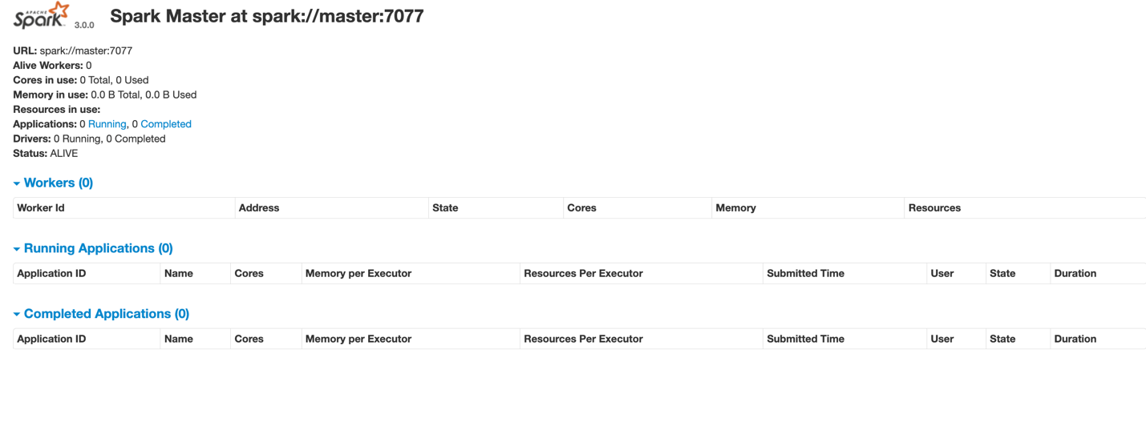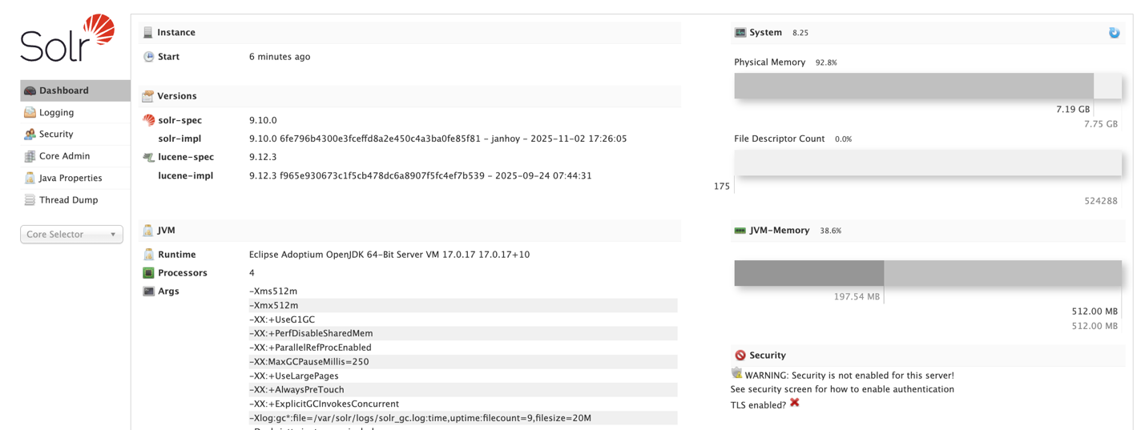
And finally we ran the nifi shell script within the nifi/bin folder to deploy the nifi application to 8443 on https. 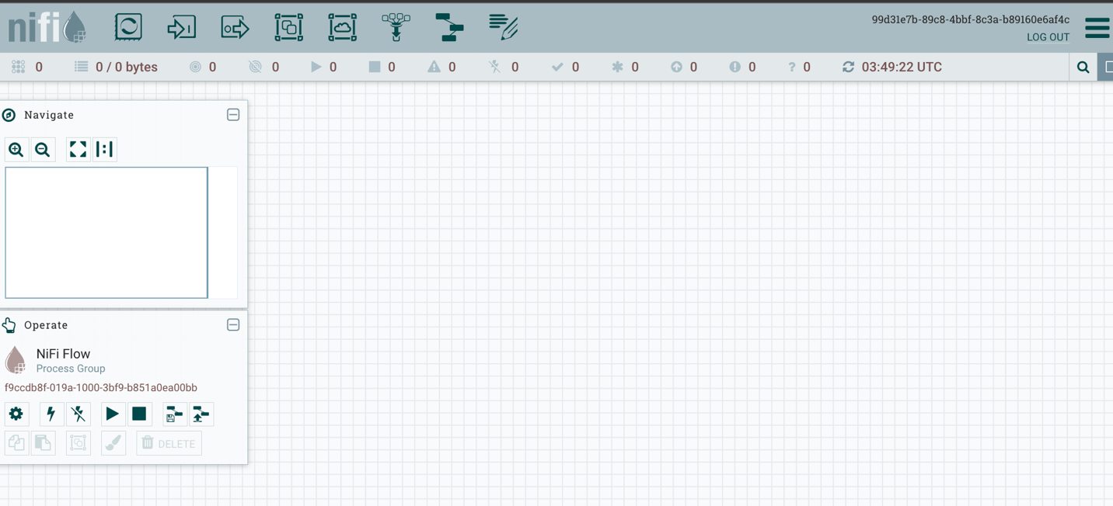
After verifying all containers were up and running, they were powered down to conserve resources. What was the purpose of this effort? Simply put, big data tasks are not commonly done on local machines. The process is highly virtualized. By familiarizing ourselves with docker and virtualization, we prove our ability to deploy the big data tools essential for work. The docker images contain exactly what we need, and we expect a smooth term given the stability of our tools. This exercise taught us to understand terminals and shells better while also setting us up for future assignments.

